Barvaro Hall

Description
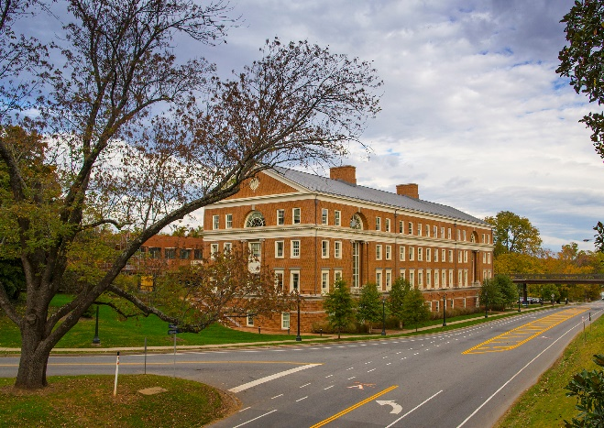
Located on a steeply sloped site on Emmet Street, at the western perimeter of the University of Virginia's historic Central Grounds, Bavaro Hall doubles the size of the Curry School of Education, currently housed in Ruffner Hall, an unremarkable 1970s building, and in clinics scattered in rented quarters. Though stylistically opposed, Bavaro Hall works together with Ruffner to define a central landscaped courtyard framed between two open-air colonnades linking the two buildings, creating a campus within a campus for the Curry School.

Newcomb Hall

Description
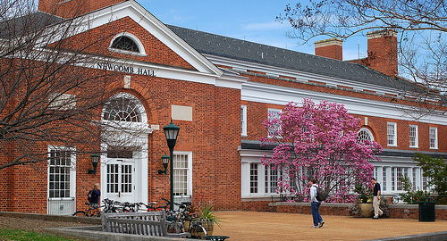
The opening of Newcomb Hall marked the dedication of University space to provide both a community gathering place and a center for student activities. Over the years, Newcomb has continuously evolved and reinvented itself to meet the needs of a dynamic University Community. Yet, even as the physical layout and amenities of the building continue to change, the purpose and objectives of the building remain consistent with the original vision.
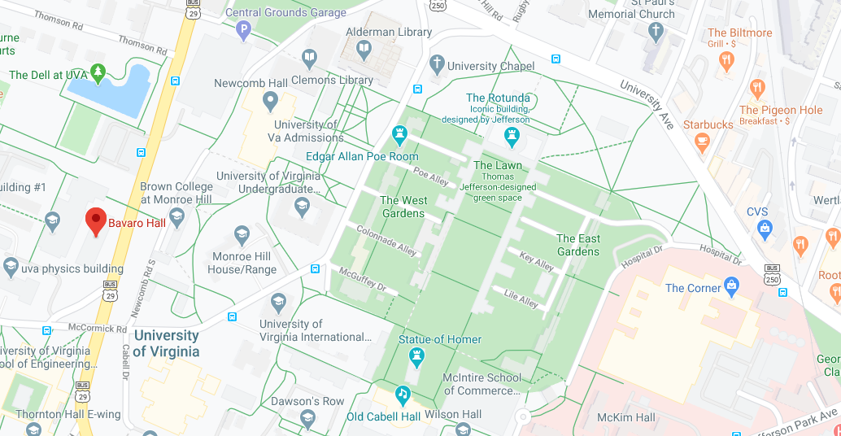
Newcomb Hall
Bavaro Hall

Pinn Hall

Description
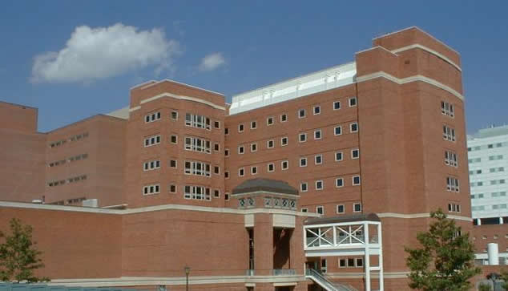
Pinn Hall is home to the University of Virginia School of Medicine, which trains future physicians and medical researchers in numerous fields. The building, which opened in 1972, is named in honor of Vivian Pinn, a 1967 graduate of the UVA School of Medicine who became the first African-American woman to chair Howard University College of Medicine's Department of Pathology and who served as the first director of the National Institute of Health's Office of Research on Women's Health.
West Complex

Description
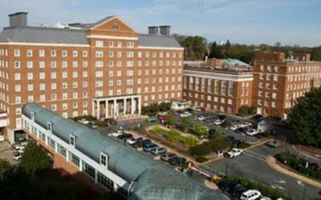
The West Complex was built as a series of separate buildings from 1901 to 1960, with major construction occurring in the 1930s and 1960s. These buildings have since been connected through a series of additions, although the names of the separate buildings are often used. These house some clinic space, offices (including SOM grants and contracts office) and a separate cafeteria. It connects to the Old Medical School building which still houses some laboratories.
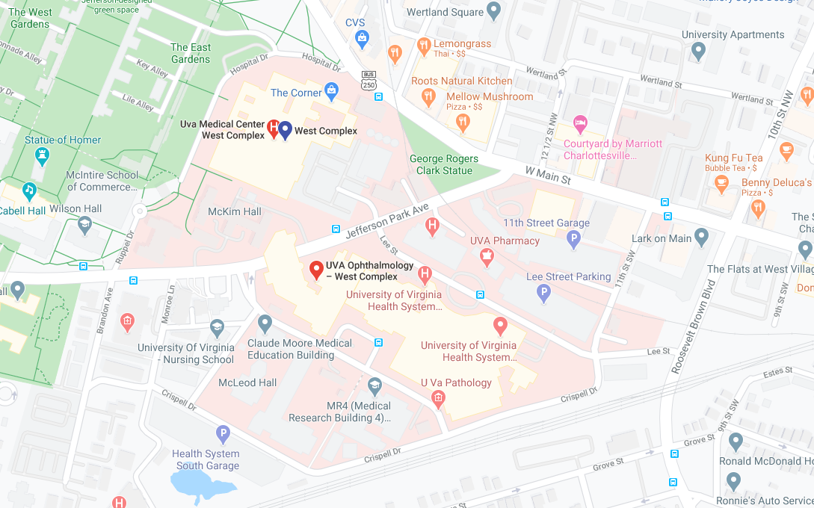
Pinn Hall
West Complex

